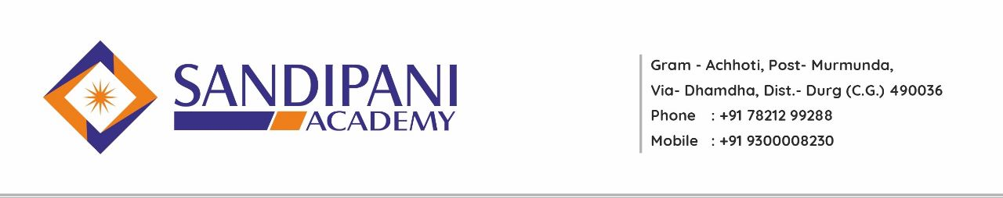
Bachelor of Education (B.Ed.)

PROGRAMME LEARNING OUTCOME (PLO)
The program learning outcomes of Two-Year B.Ed. programme are in accordance with the syllabi prescribed by Hemchand Yadav Vishwavidyalaya, Durg, C.G. The Program outcomes of B.Ed. are intended towards making the education process a more holistic experience for the pupil teachers. On the successful completion of the Two-year B.Ed. programme, the pupil teacher will able to-
- Understand nature of education and pedagogic processes through enriched experiences.
- Build and practice the right attitude, value and ethics needed for teaching profession.
- Empower themselves with the subject content and pedagogy.
- Apply teaching skills and methodology to deal with classroom problems.
- Understand and cater to the needs of the diverse students.
- Contribute to the community service programme.
- Sensitize themselves on issues related to environment protection, gender, literacy and other concurrent issues.
- Develop scientific temperament and ICT knowledge for changing technological challenges and globalisation demands.
- Attain harmonious development of their personality.
- Understand basic concepts and ideas of educational theories associated with each subject.
- Build skills and abilities of communication, effective teaching, problem solving , art and self-expression and ICT.
- Develop understanding about teaching pedagogy, school management, community involvement.
- Innovate new methods and process of teaching –learning in education.
- Develop and support society. They would be efficient enough to solve problems of the society.
- Contribute to develop the country by using their knowledge in their everyday life.
- Provide effective teaching to the school students for making their basic concepts clear.

